# Media Analysis - No need to demonize ChatGPT but AI regulation is a must _ Arab News

## Short Summary

The article discusses the rapid rise of ChatGPT, a large language model developed by OpenAI, and its impact on various sectors, particularly education and journalism.

## Summary

Summary:  
  
1. ChatGPT's impact: AI technology like ChatGPT has the potential to significantly alter various fields, including education and journalism.  
  
2. Negative consequences: There are concerns that AI tools might lead to cheating, plagiarism, and job displacement.  
  
3. Opportunities: Despite these challenges, AI can also be a leveller, providing access to information and opportunities for those in underserved areas.  
  
4. Importance of regulations: As AI technology advances rapidly, it is crucial to establish appropriate regulations to ensure its responsible use and minimize negative impacts.

## Question 1

Media coverage, including discussions about ChatGPT, often employs metaphors and frames to convey ideas and shape public perception. In the case of ChatGPT, media may use 1. **Technological innovation** ChatGPT could be framed as a cutting-edge AI tool that disrupts traditional ways of generating content. 2. **Paradoxical utility** Media might highlight how ChatGPT can help with tasks like writing articles while also raising concerns about its potential to replace human jobs. 3. **Ethical and copyright implications** Coverage may delve into the ethical dilemmas raised by ChatGPT, as well as the potential for copyright infringement when AI-generated content is too similar to original work. In summary, media coverage on ChatGPT often employs metaphors and frames that touch upon themes of technological advancement, job displacement, ethics, and copyright.

## Question 2

The perspectives and aspects that are being widely covered in the context of ChatGPT and its impact on various fields 1. **Education and Journalism** The potential disruption to traditional education methods and journalism practices due to AI-generated content. 2. **Regulation and Ethics** The necessity for regulations to address concerns around intellectual property, plagiarism, and the safety of using AI tools. 3. **Potential Benefits** The argument that AI like ChatGPT can level the playing field, provide access to information in remote areas, and support scientific research. 4. **Limitations and Accuracy** The discussion of how AI models are still prone to errors, biases, and lack of context-dependent understanding. Aspects being ignored or underemphasized 1. **AI bias and fairness** The need for continuous monitoring and addressing of AI-generated content s potential biases. 2. **Impact on human employment** While some articles discuss the threat to jobs due to AI, a more comprehensive analysis would delve into how AI can create new job opportunities as well. 3. **Long-term implications for society** Beyond short-term concerns, the article could explore how AI tools like ChatGPT may reshape societal structures, communication patterns, and even cultural practices in the coming decades.

## Question 3

The Arabic World is not explicitly mentioned in the provided text, so its role or how they leverage AI cannot be determined from the given information. Answer is Not mentioned .

## Question 4

The final message is a call for regulations to balance AI s potential benefits without causing harm or an unfair advantage.

## Sentiment

The sentiment is 3.0

## Entities

Generative Pretrained Transformer, Amal Mudallali, Disclaimer Views, READ Learning, Google, Springboard, OpenAI, The New York Times, AI, The Washington Post, Arab News, fed, Post, BBC, Midjourney, CNET

## Highlights

#7cc867#fb5b89#c885da#f9cd59

## Wordcloud for #7cc867 Highlights

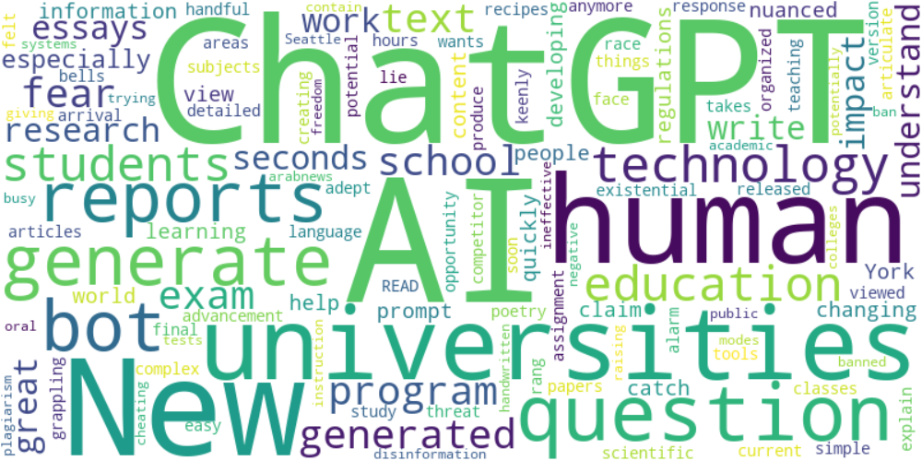

Top 10 words:

- ChatGPT: 9

- AI: 9

- human: 4

- reports: 3

- generate: 3

- bot: 3

- technology: 3

- education: 3

- universities: 3

- generated: 3

## Wordcloud for #fb5b89 Highlights

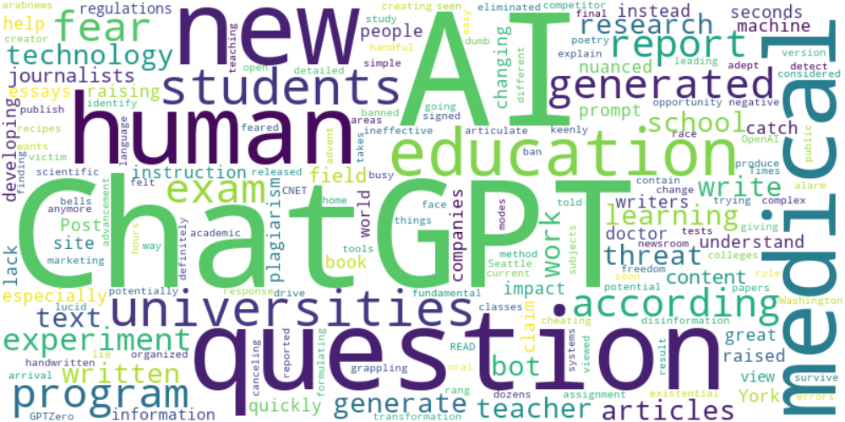

Top 10 words:

- AI: 18

- ChatGPT: 16

- human: 5

- education: 4

- question: 4

- generated: 4

- fear: 4

- questions: 4

- experiment: 4

- medical: 4

## Wordcloud for #c885da Highlights

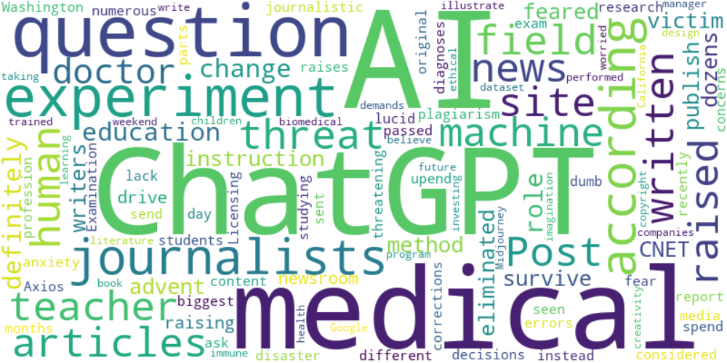

Top 10 words:

- AI: 9

- ChatGPT: 7

- experiment: 4

- medical: 4

- question: 3

- journalists: 3

- news: 2

- site: 2

- articles: 2

- according: 2

## Wordcloud for #f9cd59 Highlights

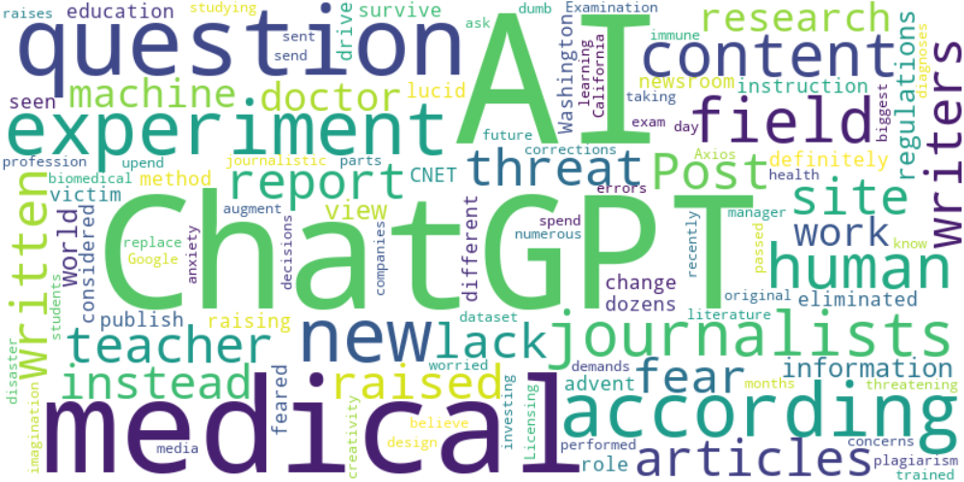

Top 10 words:

- AI: 12

- ChatGPT: 9

- experiment: 4

- medical: 4

- question: 3

- journalists: 3

- content: 3

- writers: 2

- news: 2

- site: 2